**Mini Project 1: Packet Analysis Tool**

**Objective:** Use a packet analysis tool (Wireshark) to monitor and analyze network traffic for potential security threats.

**Task 1: Packet Capture (Using Wireshark)**

Wireshark is a powerful tool that allows you to capture live network data and save it for analysis.

1. **Open Wireshark:** Launch Wireshark from the applications menu in your Kali Linux VM. You may need to run it with sudo wireshark from the terminal.
2. **Select an Interface:** You will see a list of network interfaces (e.g., eth0, ens33). Double-click the one that is active and showing traffic.

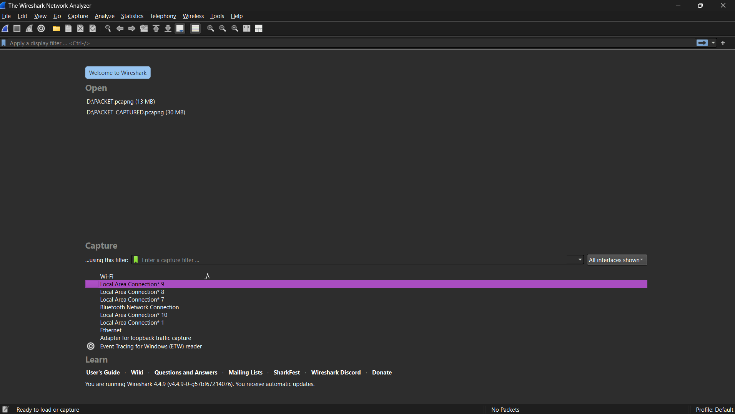

1. **Start Capturing:** The capture will begin immediately. You'll see packets scrolling in real-time.

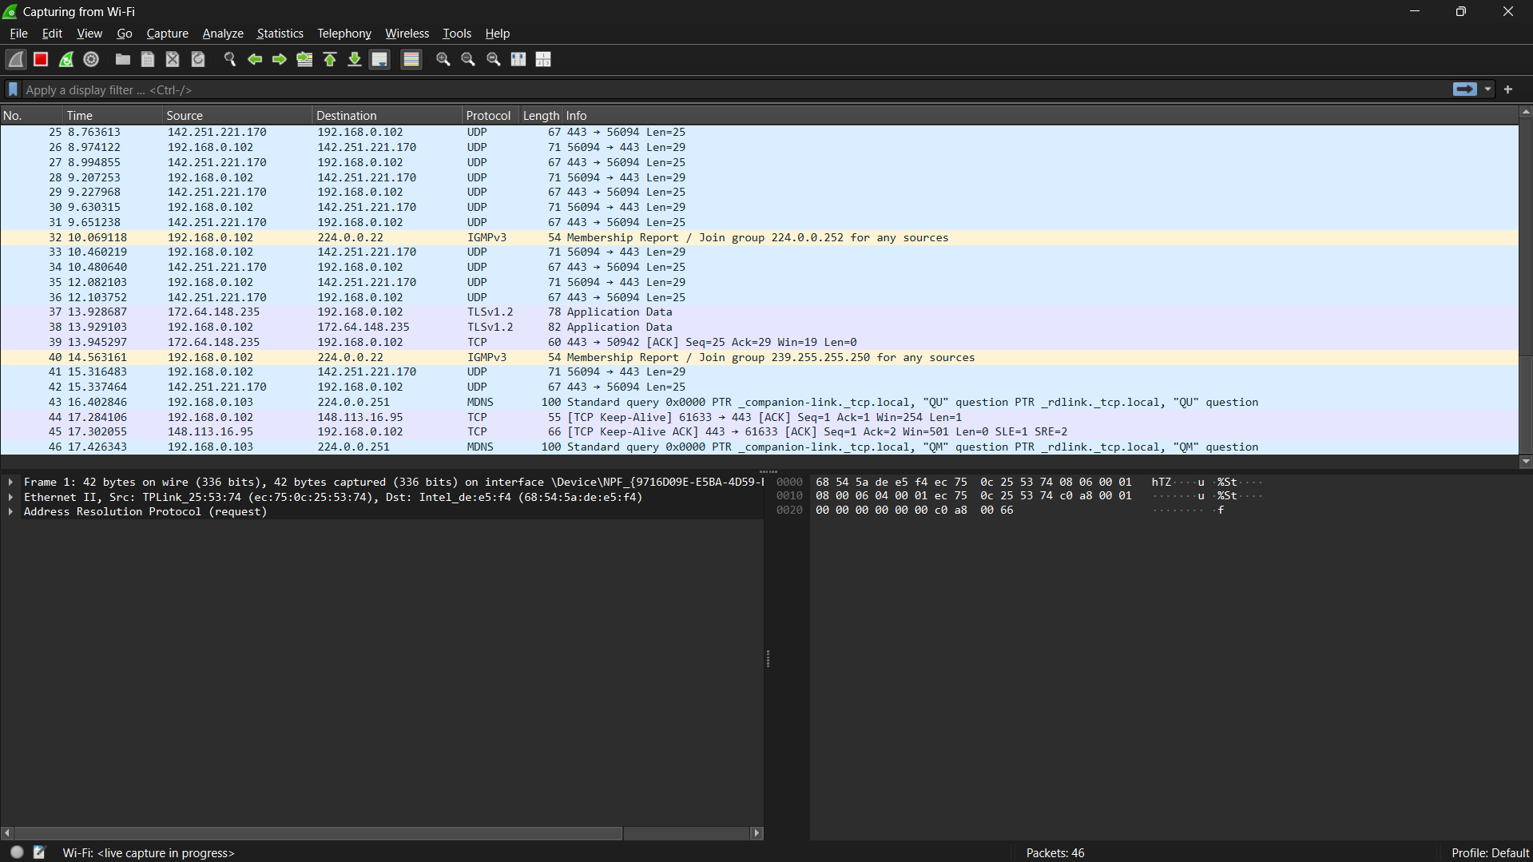

1. **Generate Traffic:** While the capture is running, perform some network activity, like browsing a website or logging into a service on your computer.
2. **Stop Capturing:** Click the red square "Stop" button in the toolbar when you have collected enough data.
3. **Save the File:** Go to **File > Save As...** to save your captured packets as a .pcapng file for your records.

**Task 2: Packet Analysis (Using Wireshark)**

This analysis is based on the screenshots you provided, which serve as a perfect example of what to look for. The key to analysis in Wireshark is using **display filters** to isolate interesting traffic.

* **Analysis of Findings (Based on Your Screenshots):**
  + **Finding 1: Secure Connection Establishment (TCP & TLS Handshake)**
    - **How to Find:** Use the filter tcp.flags.syn == 1 && tcp.flags.ack == 0 to find the start of connections. Observe the packets that follow.
    - **Observation:** The capture shows a standard TCP 3-Way Handshake (SYN, SYN-ACK, ACK) followed by a TLSv1.3 handshake (Client Hello, Server Hello).
    - **Conclusion:** This is normal behavior for establishing a secure, encrypted connection. The use of TLS is a positive security control, but it prevents an analyst from inspecting the packet's payload for threats.

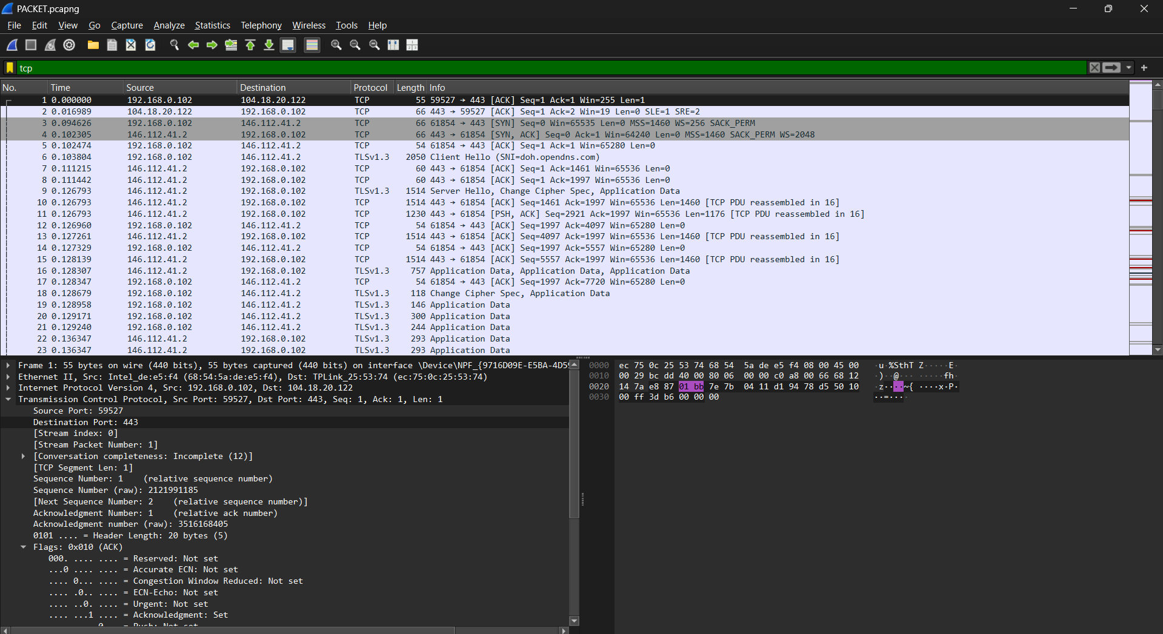

* + **Finding 2: Connection Maintenance (TCP Keep-Alive)**
    - **How to Find:** Use the display filter tcp.analysis.keep_alive.
    - **Observation:** Packets labeled [TCP Keep-Alive] and [TCP Keep-Alive ACK] are visible. These are sent during periods of inactivity to keep a session open.
    - **Conclusion:** This is normal behavior for applications requiring a persistent connection and is not inherently suspicious.

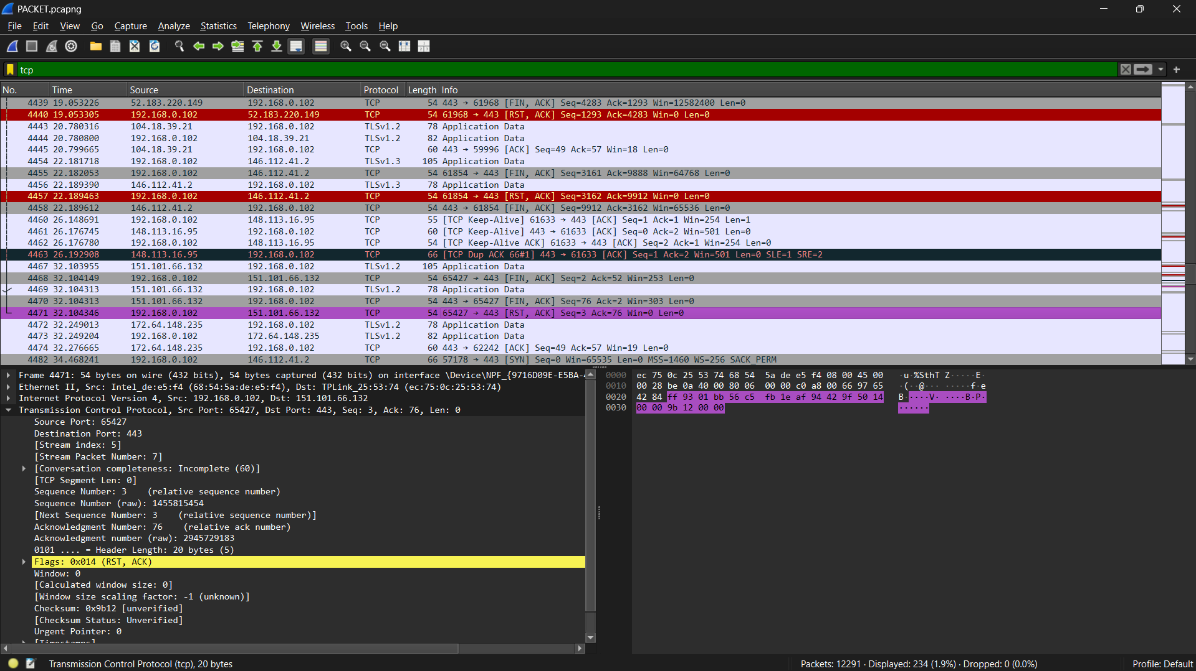

* + **Finding 3: Anomaly - Abrupt Connection Termination (TCP Reset)**
    - **How to Find:** Use the display filter tcp.flags.reset == 1.
    - **Observation:** A packet with the [RST, ACK] flags was observed. A TCP Reset (RST) flag is used to abruptly and immediately terminate a connection.
    - **Conclusion:** This is an anomaly. While not always malicious, it indicates a non-standard event, such as an application crash or a firewall blocking the connection, and warrants further investigation

.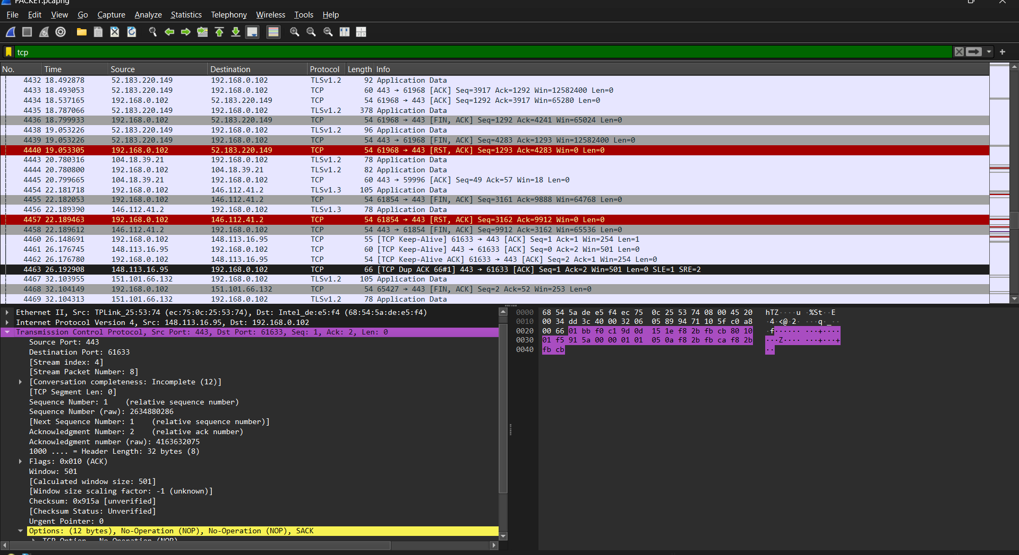

**Task 3: Reporting for Project 1**

* **Executive Summary:** "A network traffic analysis was performed using Wireshark. The analysis revealed examples of standard secure communication patterns, connection maintenance techniques, and a connection anomaly in the form of a TCP Reset."
* **Methodology:** "Live network traffic was captured and analyzed using the Wireshark graphical packet analyzer. Display filters were used to isolate and inspect specific communication patterns."
* **Findings:** Detail each finding (use the analysis from Task 2 above).
* **Recommendations:** For anomalies like a TCP Reset, recommend "further investigation of host-based logs to determine the cause of the abrupt termination."